Product Name | Brand | Image | SKU | Inclusions | Features
Mini BBQ Porch Extension | Xtend Outdoors | 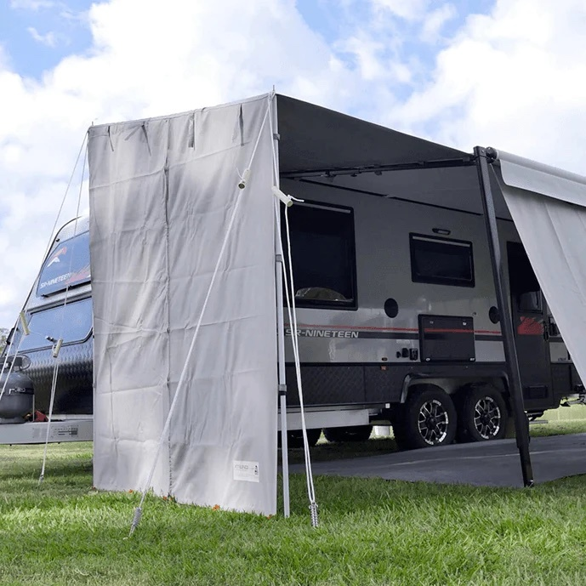 | X021008 | - 1 x Roof & End Shade Screen combination  - 2 x Twist Lock Poles  - 1 x Spreader Bar with lock  - 4 x Tie-Down Ropes  - 10 x Screw-In Pegs  - 1 x Storage Bag | - Fits the majority of awnings.  - Quick and easy set up.  - Heavy duty vinyl roof.  - Shade screen end wall with centre zip that can be rolled up separately.  - Attach to your Anti-Flap Kit or Awning Arm.  - Can be used on both ends of your awning.
BBQ Porch Awning - Small 2140mm | Xtend Outdoors | 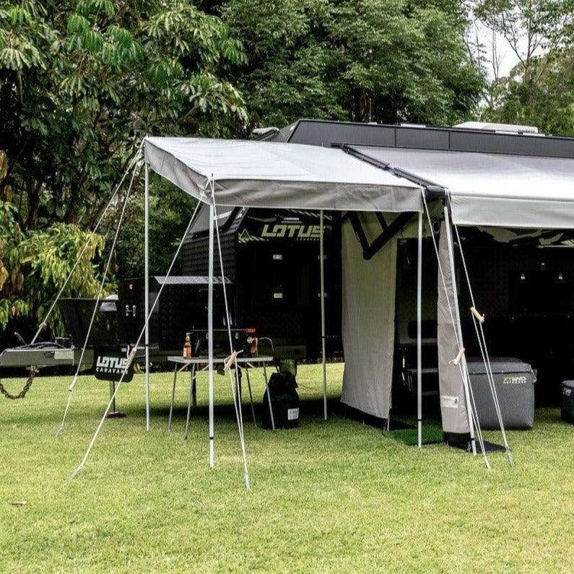 | X020412 | - 1 x Heavy duty grey vinyl canopy in carry bag  - 4 x 9ft white poles  - 3 x spreader bars  - 1 x C-Clip Curved Roof Rafter  - 6 x heavy duty steel pegs  - 6 x timber handle adjustable ropes  - 1 x carry bag for all poles | - Heavy duty vinyl roof  - Full frame design for sturdiness and support  - Velcro around edges to attach extra walls  - Reversible so it can be set up on either the front or rear of the awning  - Wind Rating 40km/hr  - Easily slides into an Anti-Flap Kit  - Anti-Flap Kit not included
BBQ Porch Awning - Medium 2270mm | Xtend Outdoors | 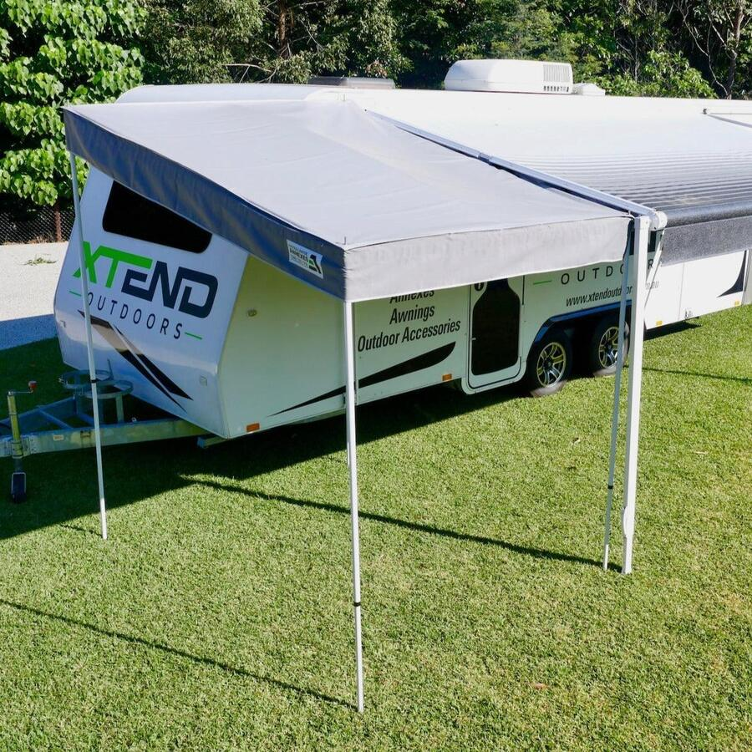 | X020413 | - 1 x Heavy duty grey vinyl canopy in carry bag  - 4 x 9ft white poles  - 3 x spreader bars  - 1 x C-Clip Curved Roof Rafter  - 6 x heavy duty steel pegs  - 6 x timber handle adjustable ropes  - 1 x carry bag for all poles | - Heavy duty vinyl roof  - Full frame design for sturdiness and support  - Velcro around edges to attach extra walls  - Reversible so it can be set up on either the front or rear of the awning  - Wind Rating 40km/hr  - Easily slides into an Anti-Flap Kit  - Anti-Flap Kit not included
BBQ Porch Awning - Large 2340mm | Xtend Outdoors | 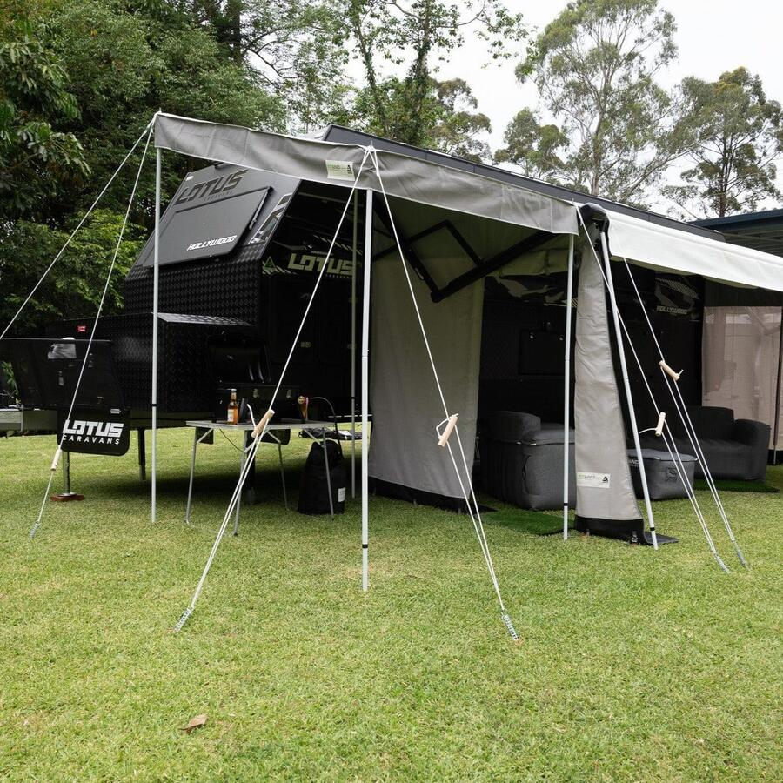 | X020414 | - 1 x Heavy duty grey vinyl canopy in carry bag  - 4 x 9ft white poles  - 3 x spreader bars  - 1 x C-Clip Curved Roof Rafter  - 6 x heavy duty steel pegs  - 6 x timber handle adjustable ropes  - 1 x carry bag for all poles | - Heavy duty vinyl roof  - Full frame design for sturdiness and support  - Velcro around edges to attach extra walls  - Reversible so it can be set up on either the front or rear of the awning  - Wind Rating 40km/hr  - Easily slides into an Anti-Flap Kit  - Anti-Flap Kit not included
Waterproof XD Caravan Awning Porch Extension (Square Cut) | Campsmart | 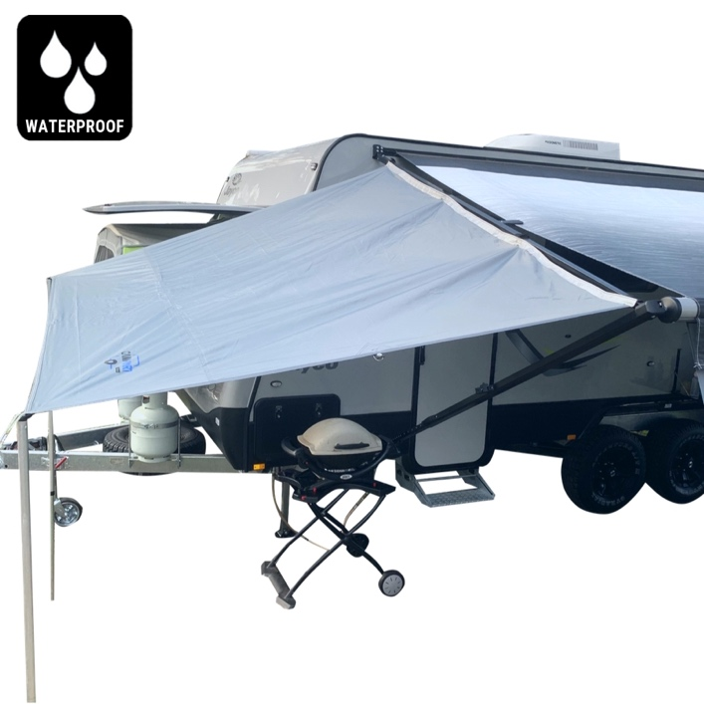 | CSPS020WP | - Includes a convenient zippered carry bag;  - Includes guy ropes & steel zinc plated pegs (with peg bag) for privacy screen mode. | - D-Rings plus Eyelets on re-enforced tabs (3 bottom plus 2 side points);  - Kedar rope spline that won't kink over time (for fitting to AFKs);  - 5 Velcro Straps (for fitting to awning cross bar)  - Hemmed edging all around to prevent fraying;  - 2 x Side attachment points for attachment to awning Legs;  - Provides excellent privacy and shade;  - Easy & quick to set up;  - Suitable for use with all popular roll out awning brands;

